**IMB HR EXPLOTORY DATA ANALYSIS**

**Breanyl Baker**

Doing an Exploratory Data Analysis on fictional HR data from IBM.

**NUMBER OF EMPLOYEES**

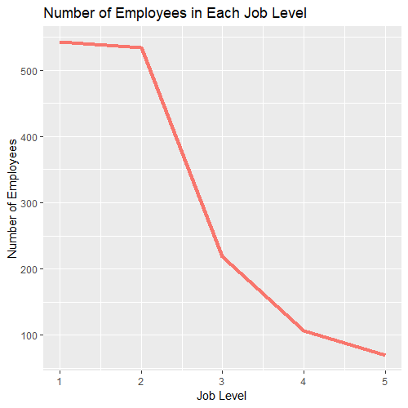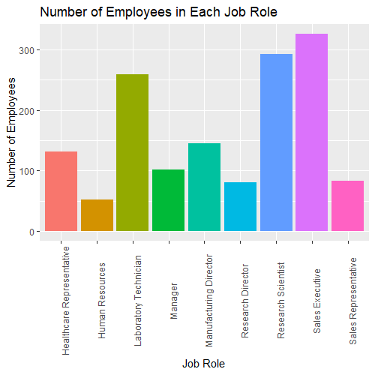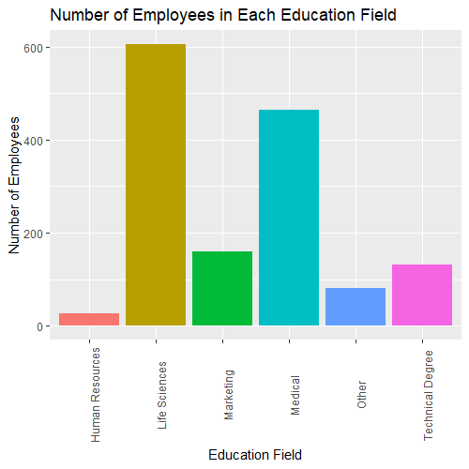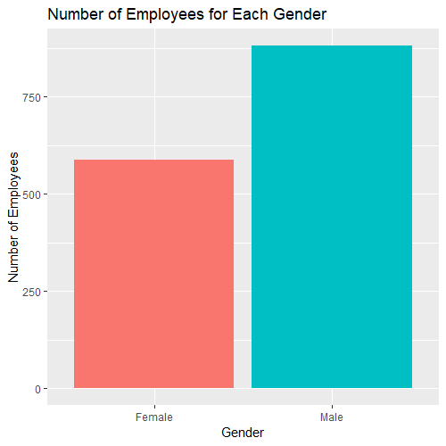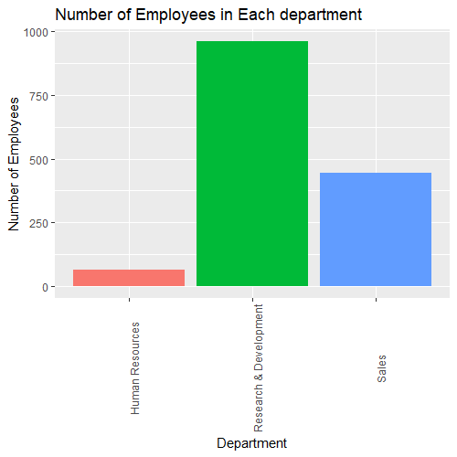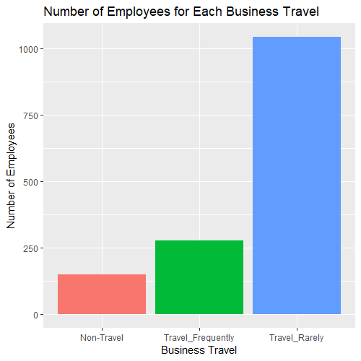There is a total of 1470 employees.

Most employees travel rarely, are in the Research and Development department as well as positioned in level one jobs. There are more male employees than female and most employees are married. The educational field with the most employees is Life science while most employees are Sales Executives.

**AVERAGE AGE**

All employees are over 18 and the maximum age at the company is 60. The average age is about 37. There isn’t much of a difference between the average age for some of the grouped variables. So, I changed the y axis scale so the difference could be seen more clearly.

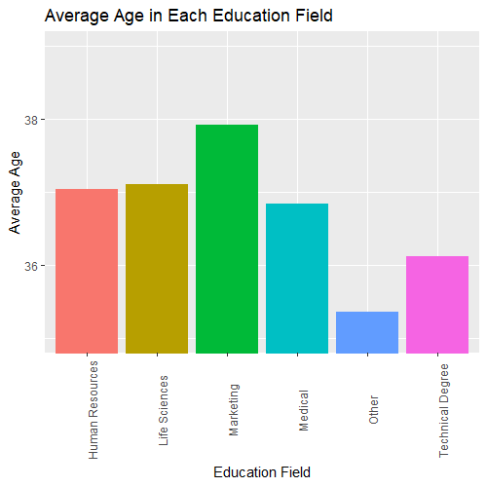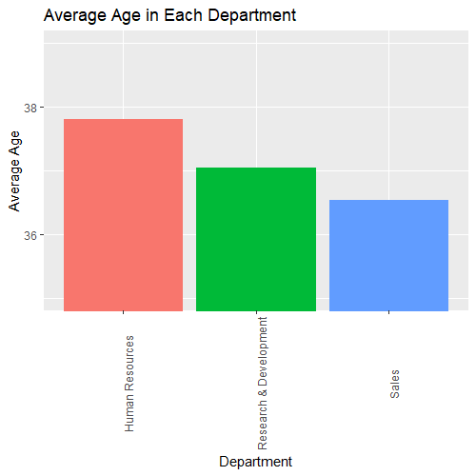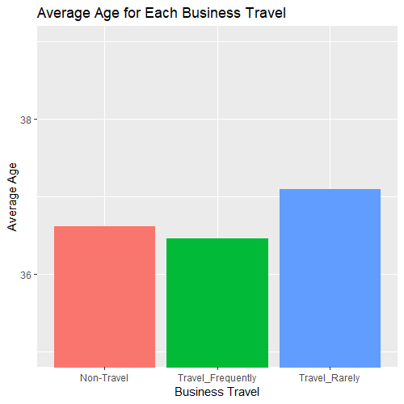

Employees that travel rarely are the oldest. Employees in the Marketing education field are the oldest, while employees in the Human Resources department are the oldest employees. Level 5 and 4 job level employees are the oldest as well as job role Manger.

**MONTHLEY INCOME**

Maximum monthly income among employees is $19999 while the minimum is $1009. The average monthly income among employees is $6502.93 though.

Employees that travel rarely have the highest monthly income. Employees in the Sales department have the highest monthly income but the highest monthly income among all employees is from the Research and Development department. Female employees have the higher monthly income, but the highest monthly income is from a male. Level 5 employees and Managers have the highest monthly income.

Therefore, the highest monthly income employee is a male manager in a level 5 role working in the research and development department that travels rarely.

**PERCENT SALARY HIKE**

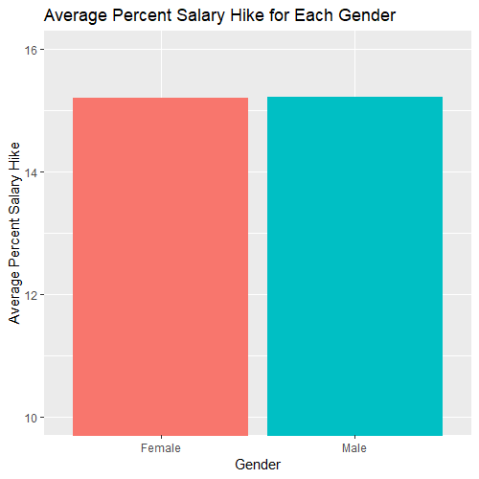The maximum hike in percent salary is 25 while minimum is 11. The average hike in percent salary is 15.21. There isn’t much of a difference between the average hike in percent salary for some of the grouped variables. So, I changed the y axis scale so the difference could be seen more clearly.

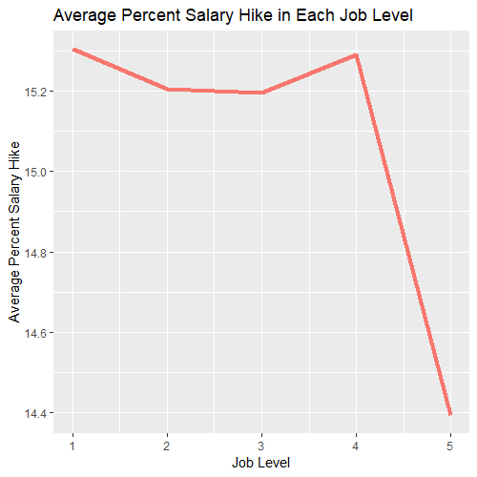

Employees that don’t travel have the highest percentage hike in salary. Employees in the Research and Development department have the highest percentage salary hike, while Sales representatives job role has the highest. Females and males have the same percent salary hike. Level one job employees have the highest percentage hike in salary.

Therefore, even though Sales representative is a level one job and they both have the highest salary hike, the Research and Development department salary hike is higher than the Sales department.

**ENVIRONMENT SATISFACTION**

Among all employees the average environment satisfaction was 3.

In the Research and Development department only Health Representative voted the least for environment satisfaction, which was 3 while the rest of the job roles voted 4. In the Human Resources department all job roles voted mostly for 3. In the Sales department only, Managers voted 4 in environment satisfaction while the rest of the job role voted 3.

Therefore, all job roles in their department vote the most for 3 at least for environment satisfaction.

**JOB SATISFATION**

Among all employees the average job satisfaction was 3.

In the Research and Development department half the jobs voted 4 for job satisfaction and the next half was 3. In the Human Resources department Mangers votes mostly 2 and 4 for job satisfaction while Human Resources voted 2. In the Sales department most job roles voted job satisfaction as 4, just the Sale Representatives voted 3.

Therefore, the Human Resources department is the department with the least job satisfaction vote among the departments.

**YEARS AT COMPANY, YEARS SINCE LAST PROMOTION AND YEARS IN CURRENT ROLE.**

The average year at the company is 7 years, years since promotion is 2 years, and years in their current role is 4 years for all employees.

Business Travel and gender years at company, years since last promotion and yeas in current role is the same as the average for all employees. Level 5 and 4 jobs spend the longest at the company while the lower levels 1 and 2 spend the shortest. The higher-level jobs 5 and 4 have the longest time since the last promotion while the lower-level jobs 1 and 2 have the shortest time since the last promotion. Level 4 jobs spend the longest in current role while the lower levels also spend shorter time in current role.

Therefore, it seems that level 4 jobs have the most retention among all the levels.

**OVERALL**

Those that don’t travel benefit and stay the longest.

I would say that the Research and development department is the most rewarding. Even though it has the lowest monthly income, which could have been because most employees work in that department. It does have the highest hike in salary percent. As well as the best votes in environment and job satisfaction.

It seems that the higher-level jobs are the managers, research directors, and health representatives. They tend to stay at the company longer and have a higher monthly income. As well as vote mostly 4 for job and environment satisfaction.

Therefore, the higher you go in job level the more benefit and better satisfaction in your job and environment.